Morocco

## Respect for rule of law (ROL) data

The data set shows the data on the respect of the rule of law for the country.

## # A tibble: 19 x 5  
## country iso3c date ruleOfLaw ruleOfLawCategory4   
## <chr> <chr> <dbl> <dbl> <chr>   
## 1 Morocco MAR 1996 0.221 ROL moderately respected   
## 2 Morocco MAR 1998 0.233 ROL moderately respected   
## 3 Morocco MAR 2000 0.129 ROL moderately respected   
## 4 Morocco MAR 2002 -0.0203 ROL moderately disrespected  
## 5 Morocco MAR 2003 -0.0757 ROL moderately disrespected  
## 6 Morocco MAR 2004 -0.0326 ROL moderately disrespected  
## 7 Morocco MAR 2005 -0.165 ROL moderately disrespected  
## 8 Morocco MAR 2006 -0.290 ROL moderately disrespected  
## 9 Morocco MAR 2007 -0.299 ROL moderately disrespected  
## 10 Morocco MAR 2008 -0.303 ROL moderately disrespected  
## 11 Morocco MAR 2009 -0.210 ROL moderately disrespected  
## 12 Morocco MAR 2010 -0.172 ROL moderately disrespected  
## 13 Morocco MAR 2011 -0.228 ROL moderately disrespected  
## 14 Morocco MAR 2012 -0.209 ROL moderately disrespected  
## 15 Morocco MAR 2013 -0.248 ROL moderately disrespected  
## 16 Morocco MAR 2014 -0.0651 ROL moderately disrespected  
## 17 Morocco MAR 2015 -0.0889 ROL moderately disrespected  
## 18 Morocco MAR 2016 -0.158 ROL moderately disrespected  
## 19 Morocco MAR 2017 -0.175 ROL moderately disrespected

## Respect for rule of law (ROL) trend

The plot shows the trend of the respect for the rule of law for the country.

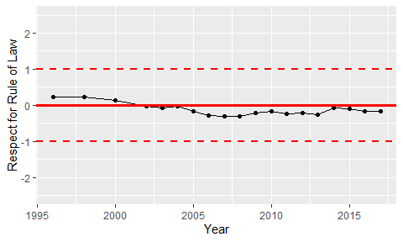

Trend of the Respect for the Rule of Law